**National University of Computer & Emerging Sciences, Karachi** **Spring 2021**Assignment I

**Submission:**

* You'll need to submit a single .***docx*** file containing separate solutions for each task
* Before submission, rename your file as your ID e.g. ***k20-1234.docx***
* **Deadline:** *Monday, 30th of April, 2021 (07:00 am)*
* To be submitted on Google Classroom *(code:* cj6dvs2*)*

**Q1.** The circuit Figure-1 is supposed to be a simple digital combination lock whose output will  
generate an **active –LOW** signal for only one combination of inputs. Modify the circuit diagram for **active low output** and write down the statement.

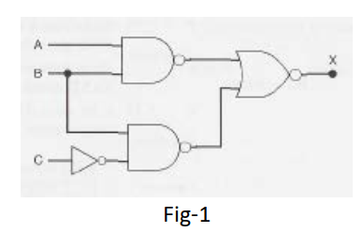

**Q2.** Develop a logic circuit with four input variables that will only produce a binary ‘1’ output when exactly three input variables are binary 1s.

**Q3.** Write down the logic for converting a six bit binary number into gray code. Draw the logic diagram as well.